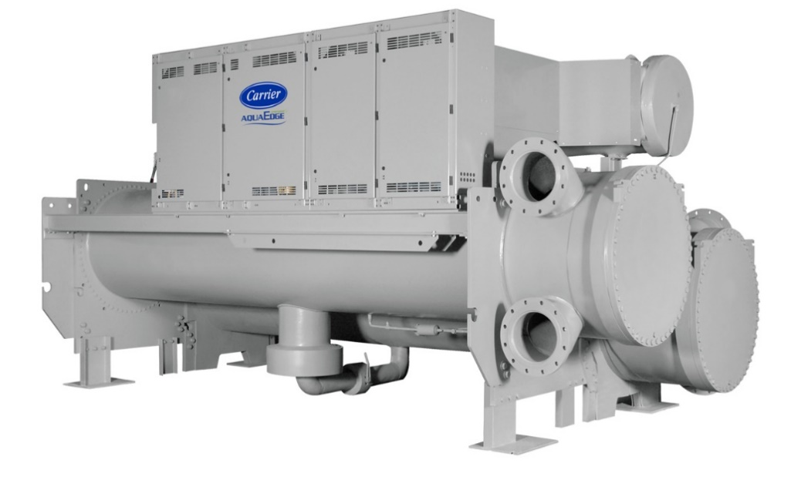
Device Information
Chiller Number | 5111Q21335
Location Name | Research Foundation of SUNY Albany Nanotech
Location City | Albany
Postal Code | 12203
Site Address | 257 Fuller Rd, Albany, NY
Time-zone | America/New_York
Year of Manufacturing (Age) | 2011(13 Years)
Model Number | 19XRV56574TELEH64S
Report Duration | 2022-09-27 ~ 2023-12-24
Chiller Run Hours | 53,113

Summary
As part of Carrier’s connected chiller program our command center experts continuously monitor performance and health of your chiller and its major components to provide real time feedback and less operational disruption.
Your chiller serial number 5111Q21335 was evaluated for Chiller Replacement Analysis. Further Analysis is performed from the real time data from 2022-09-27 to 2023-12-24. The design efficiency of current chiller is 0 kW/T. The overall efficiency of this chiller is 0.6 kW/T. Replacing this with a Carrier Aqua Series Water Cooled Chillers can improve the overall efficiency to 0.39 kW/T. This replacement can improve the chiller efficiency by 35%. The chiller is running at low loads (<60% RLA) for 54% during the analysis period and this replacement can enhance design integrated part-load values (IPLV) to as low as 0.37 kW/T.
Chiller Replacement Benefits:
- Improved Efficiency
- Reduces operating expenses.
- Easy to maintain.
- Quiet operation
- Reliable operation
- Environmentally sustainable refrigerant
- ASHRAE 90.1 compliant
- High-efficiency optimization
- Diagnostic controls
Based on the performance of the chiller operation versus measured parameters, Carrier recommends further evaluation of the Chiller Replacement by our certified technician. This will ensure optimal performance of the Chiller.
Alarm/Setpoint Analysis

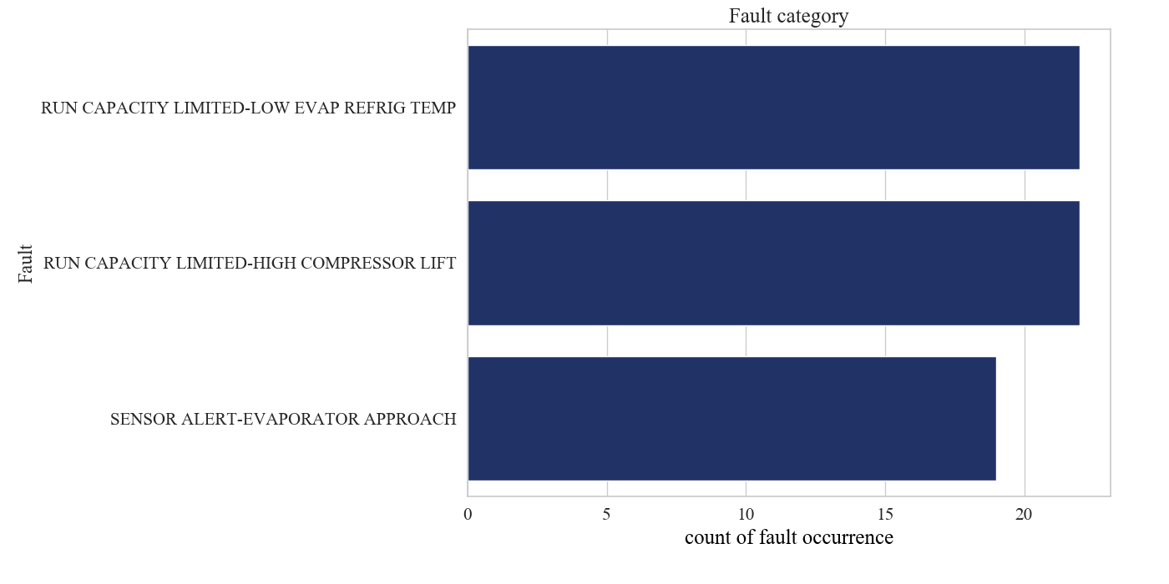
The analysis result show that setpoint not meeting 0% of time.
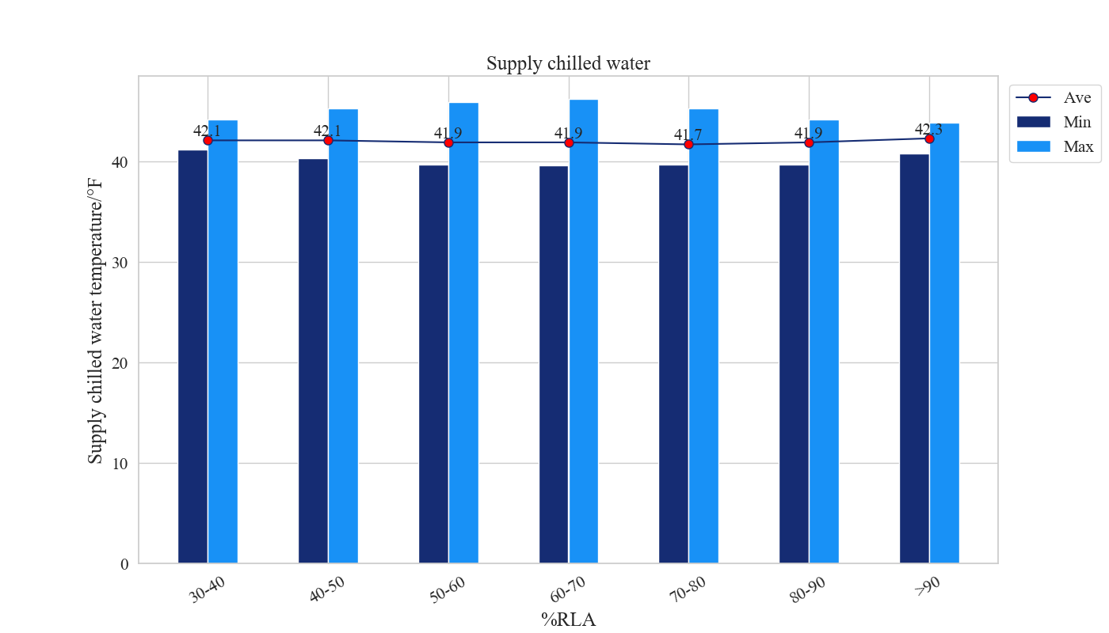
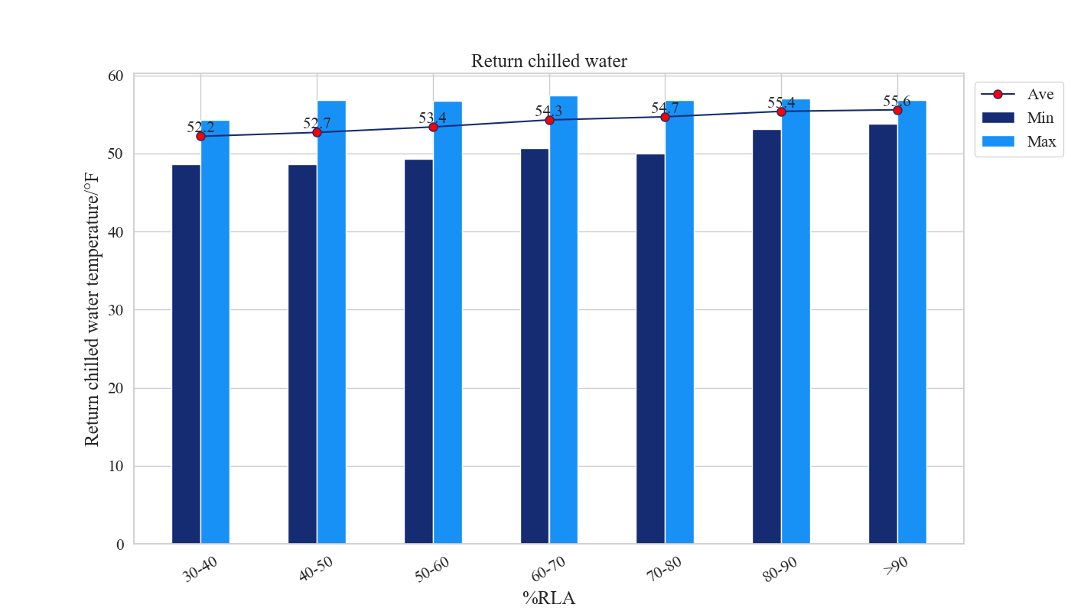

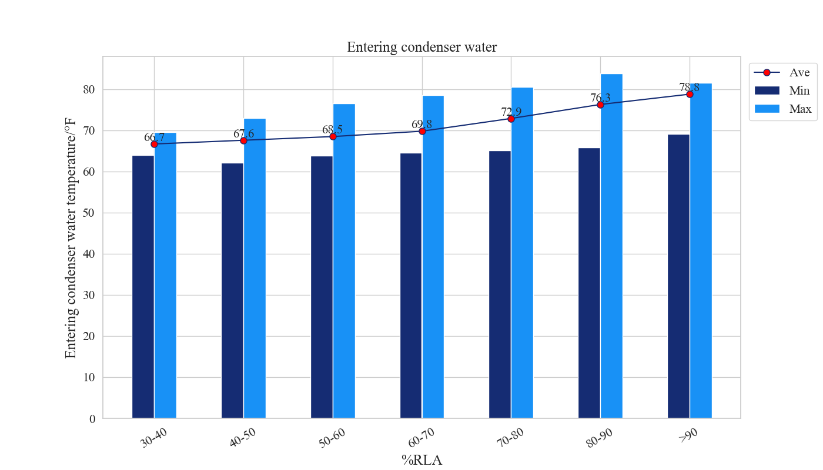
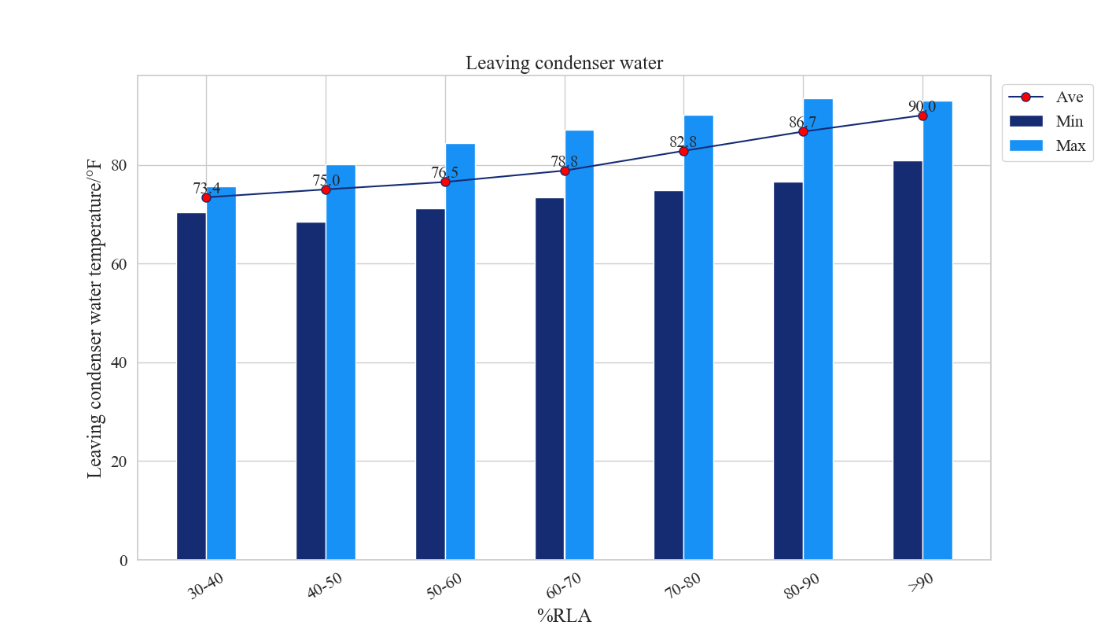
Comments
The Average Cooler supply water temperature is between 41.7 to 42.3 (°F) and the average Condenser entering water temperature is between 66.7 to 78.8 (°F).
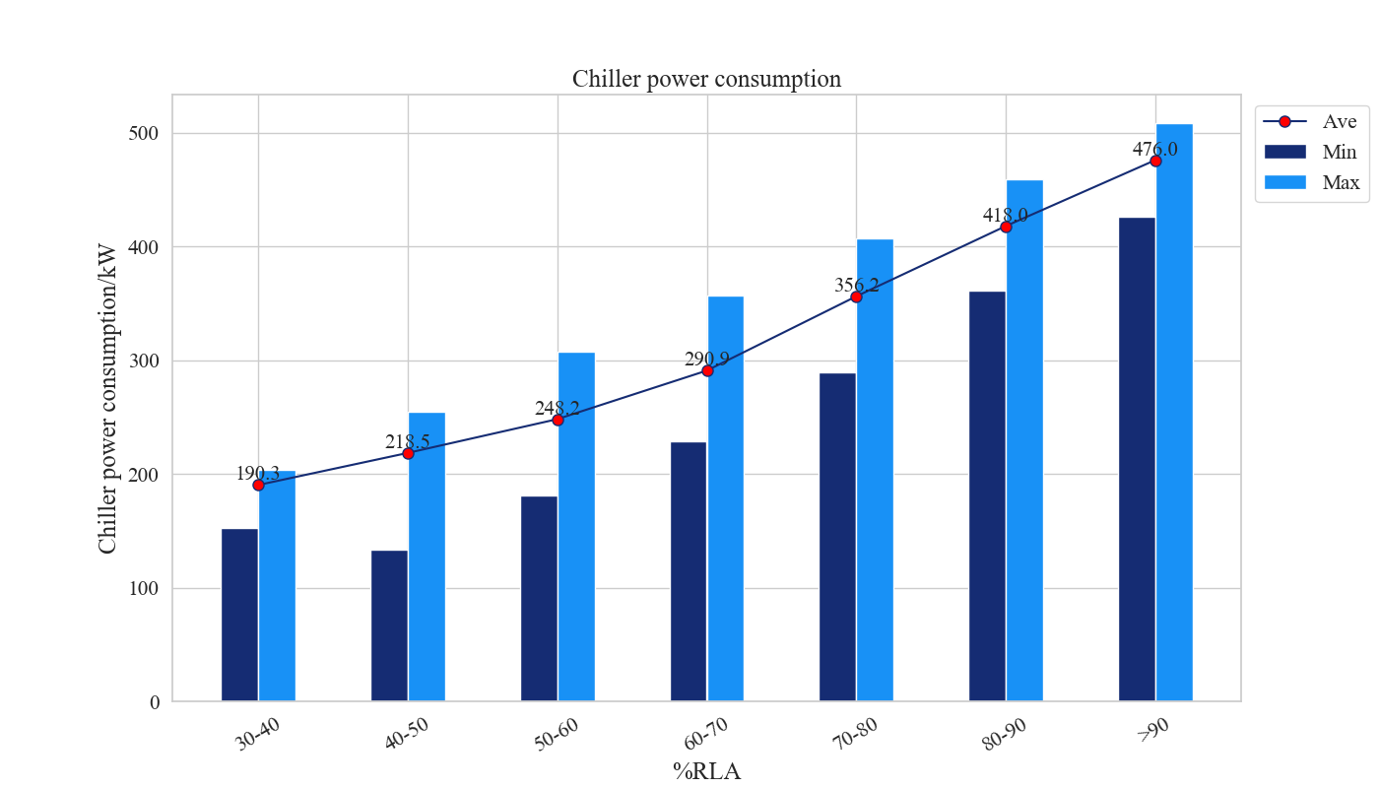
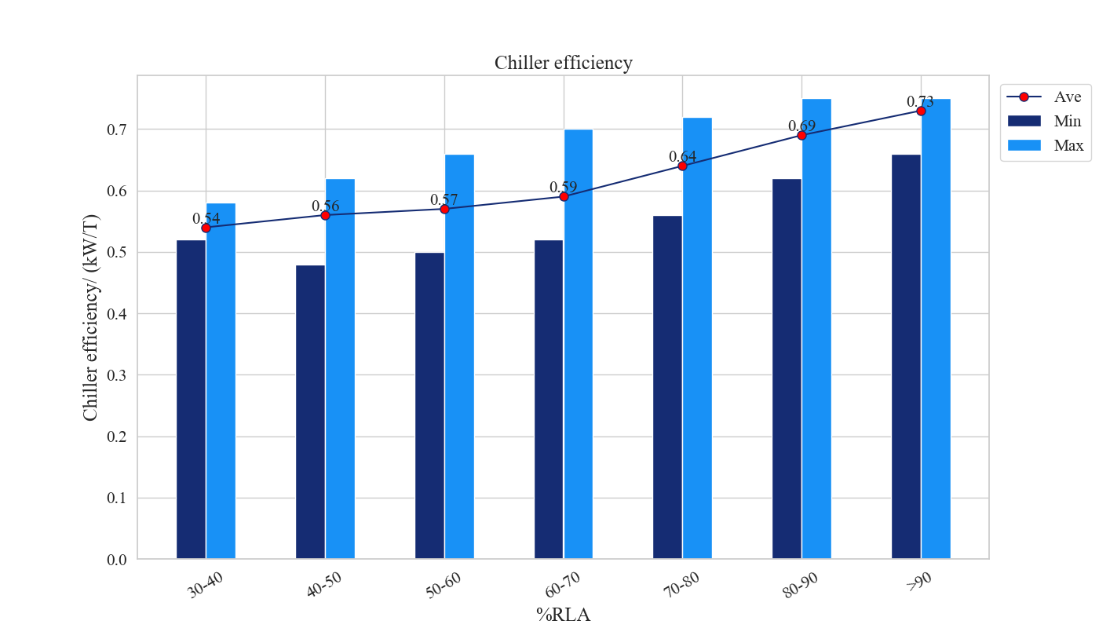
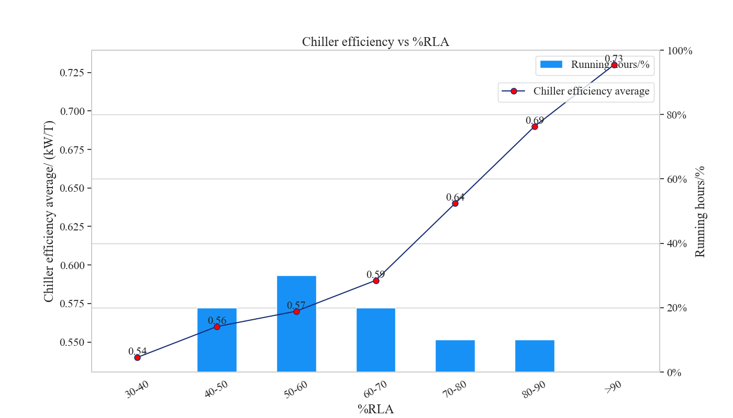
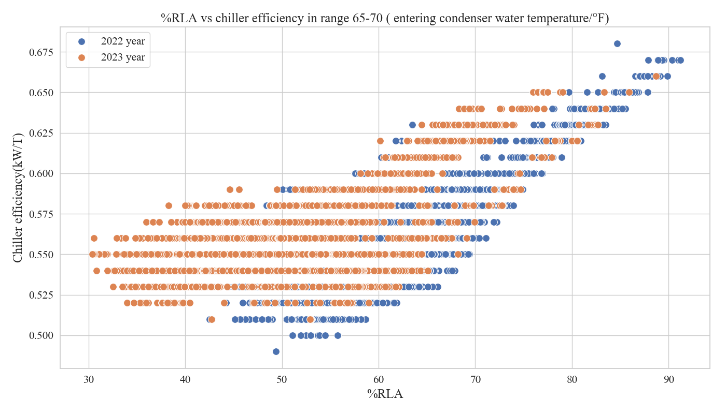
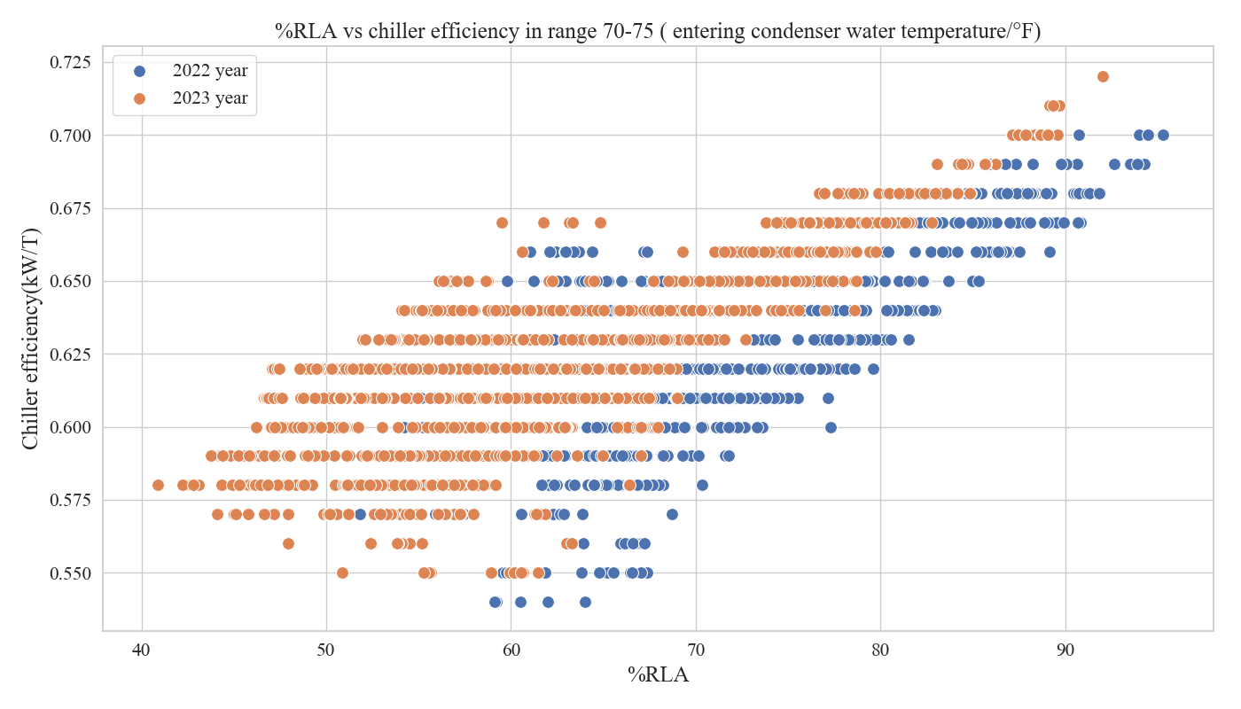
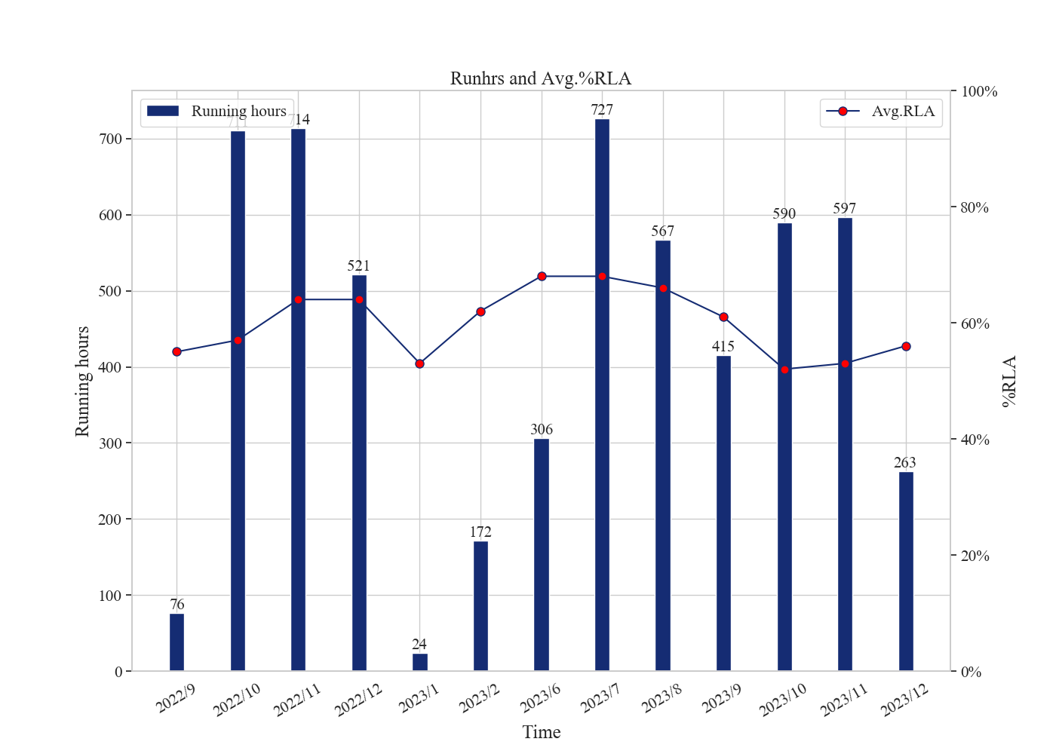
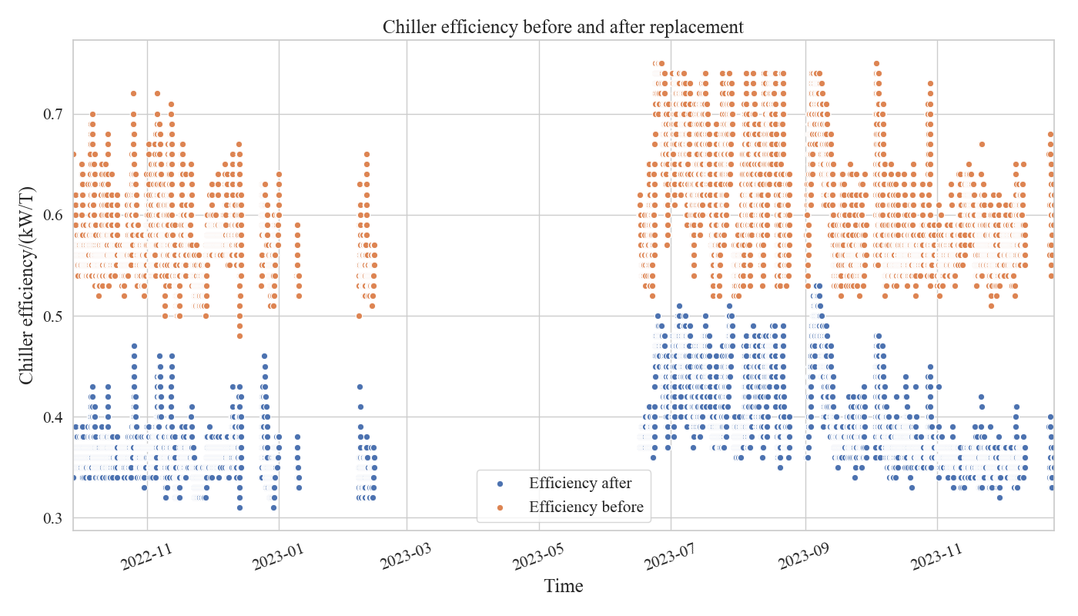
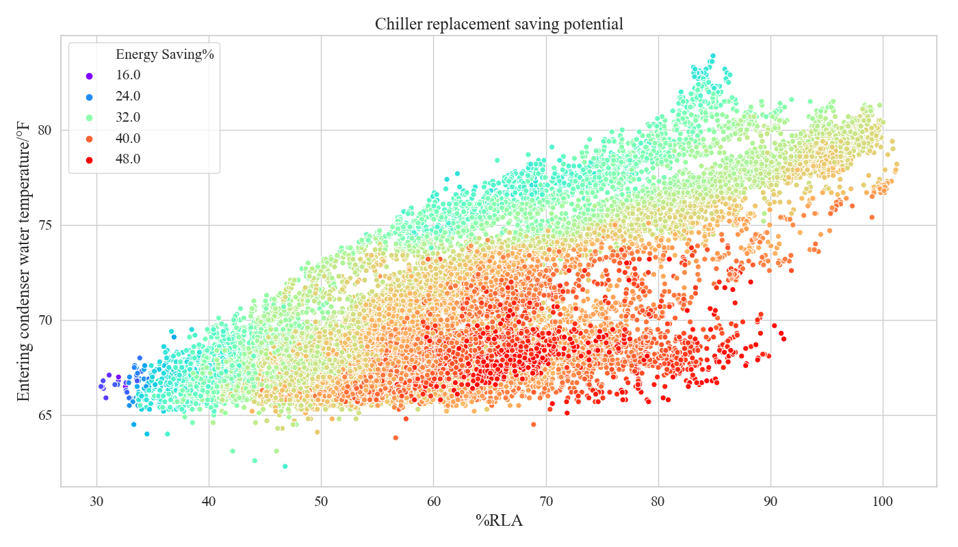
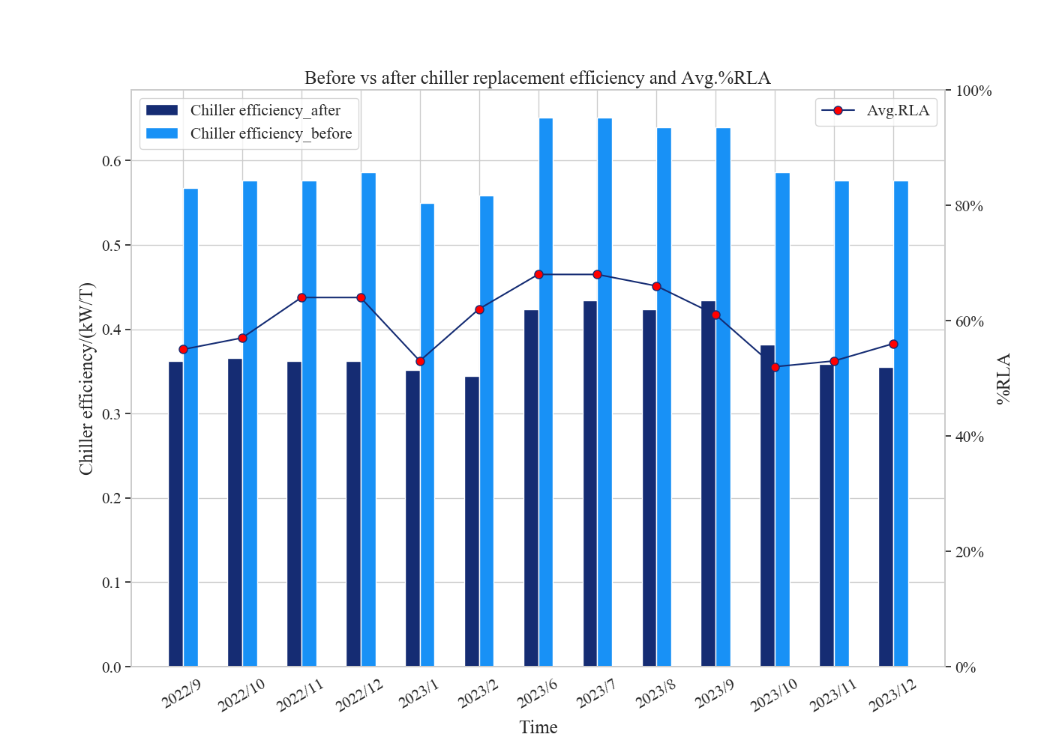
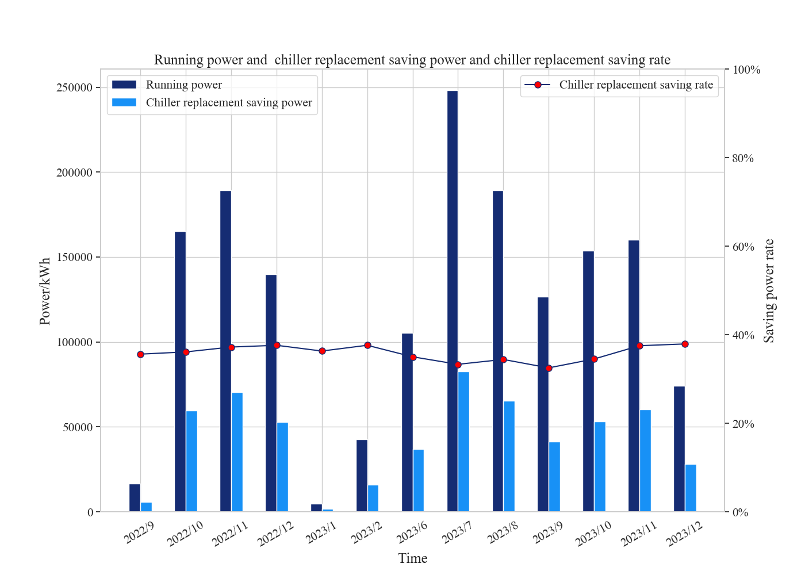
Chiller Sub System Health

Chiller # |  | Condenser Health (Good/Stage of Degradation) | Evaporator Health (Good/Stage of Degradation) |  | Compressor Performance (Good/Stage of Degradation) | Ref leak (Good/Stage of Degradation) | Condenser Water Flow Issue (Yes/No) | Evaporator Water Flow Issue (Yes/No)
5111Q21335
S1 | No action required
S2 | Plan to clean/fix
S3 | Clean/Fix immediately
S4 | -
Summary
Energy Efficiency Improve | 35%
Energy Savings | 573,357 kWh
Energy Savings/per year | 461,976 kWh
Investment pay-back period | 4.4 Years

